Seth Ricks: ECEN 380 (Signals and Systems)
Even: x(-t)=x(t); Even component:$x_{e}\left(t\right)=\frac{1}{2}[x\left(t\right)+x\left(-t\right)]$; Odd: x(-t)=-x(t); Odd component: $x_{o}\left(t\right)=\frac{1}{2}\left[x\left(t\right)-x\left(-t\right)\right]$ Periodic: x(t)=x(t+T) for all t; $ω=2πf=\frac{2π}{T}$;
Ex;$y\left(t\right)=12\cos\left(35t\right)+10\sin\left(49t\right)$; $T_{1}=\frac{2π}{35};T_{2}=\frac{2π}{49};T_{0}mT_{1}=nT_{2};$ $\frac{m}{n}=\frac{T_{2}}{T_{1}}=\frac{5}{7};T_{0}=5T_{1}=7T_{2}=\frac{2π}{7}$;; $\cos\left(ωt\right)=\frac{e^{jωt}+e^{-jωt}}{2}; \sin\left(ωt\right)=\frac{e^{jωt}-e^{-jωt}}{2j};e^{jωt}=\cos\left(ωt\right)+jsin\left(ωt\right)$
$To get y\left(t\right)=x\left(at-b\right), shifting must be done before scaling$; $δ\left(t\right)=\frac{d}{dt}u\left(t\right)$; Determine characteristics: Ex;$y\left[n\right]=2x\left[n\right]u\left[n\right]$ $doesn^{'}t depend on past or future→memoryless$
$depends only on the present→causal$; $output is finite\left(no n in equation\right)→stable$; $x\left[n\right]=ax_{1}\left[n\right]+bx_{2}\left[n\right]$; $y\left[n\right]=2\left(ax_{1}\left[n\right]+bx_{2}\left[n\right]\right)u\left[n\right]$
$x\left[n\right]=ax_{1}\left[n\right]→y\left[n\right]=2ax_{1}\left[n\right]u\left[n\right]$; $x\left[n\right]=bx_{1}\left[n\right]→y\left[n\right]=2bx_{2}\left[n\right]u\left[n\right]; 2ax_{1}\left[n\right]u\left[n\right]+2bx_{2}\left[n\right]u\left[n\right]=2u\left[n\right]\left(ax_{1}\left[n\right]+2bx_{2}\left[n\right]\right)→Linear$; $y_{2}\left[n\right]=2x_{1}\left[n-n_{0}\right]u\left[n\right]$
$y_{1}\left[n-n_{0}\right]=2x_{1}\left[n-n_{0}\right]u\left[n-n_{0}\right]→y_{1}\left[n-n_{0}\right]≠y_{2}\left[n\right]→Time Variant$; $Derivatives and integrals only depend on PAST values, not future(This class)$
$block diagram:ρ→mult., S→minus 1;ρ=1\left(unstable\right)→y\left[n\right]=\sum_{k=0}^{∞}{x\left[n-k\right]→accumulator}$; $\left|ρ\right|<1→leaky accumulator, leakage smaller as ρapproaches unity$(stable)
$$\left|ρ\right|>1→amplified\left(unstable\right)$$
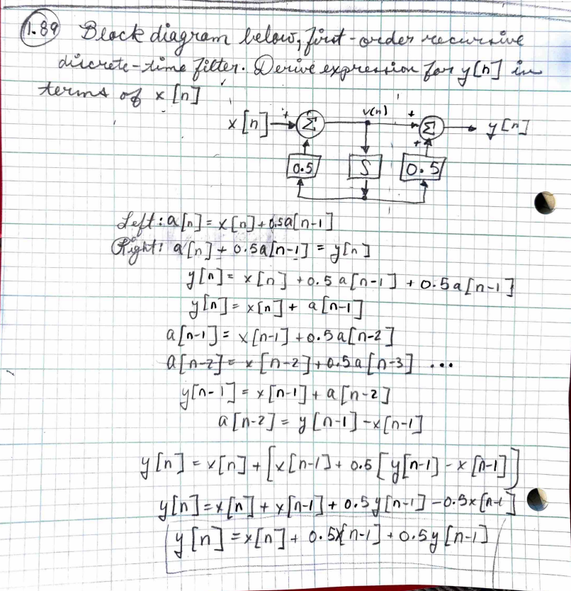
$Left:a\left[n\right]=x\left[n\right]+0.5a\left[n-1\right]$; $Right:a\left[n\right]+0.5a\left[n-1\right]=y\left[n\right]$
$$y\left[n\right]=x\left[n\right]+0.5a\left[n-1\right]+0.5a\left[n-1\right]$$
$$y\left[n\right]=x\left[n\right]+a\left[n-1\right]$$
$$a\left[n-1\right]=x\left[n-1\right]+0.5a\left[n-2\right]$$
$$a\left[n-2\right]=x\left[n-2\right]+0.5a\left[n-3\right]…$$
$$y\left[n-1\right]=x\left[n-1\right]+a\left[n-2\right]$$
$$a\left[n-2\right]=y\left[n-1\right]-x\left[n-1\right]$$
$$y\left[n\right]=x\left[n\right]+[x\left[n-1\right]+0.5y\left[n-1\right]-x\left[n-1\right]]$$
$$y\left[n\right]=x\left[n\right]+x\left[n-1\right]+0.5y\left[n-1\right]-0.5x\left[n-1\right]$$
$$y\left[n\right]=x\left[n\right]+0.5x\left[n-1\right]+0.5y[n-1]$$
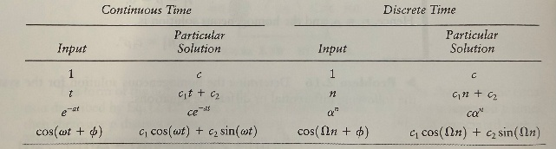
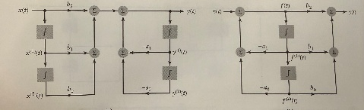

$$A^{'}=TAT^{-1};b^{-1}=Tb;c^{'}=cT^{-1} and D^{-1}=D, then$$
${\dot{q}}^{'}=A^{'}1+b^{'}x;y=c^{'}1+D^{'}x$
Summary of how to solve for the homogenous, particular, natural, and forced responses. Homogenous (discrete): For discrete, start at the lowest index, that is your constant with
no rs. then go up. ex; y[n]-1/9y[n-2]=x[n-1] -> r^2 +0r -1/9 = 0 -> r = +-1/3 y(h)[n] = c_1(-1/3)^n + c_2(1/3)^n
Homogenous (continuous): For continuous, start with highest order derivative, that is highest r, work way down. ex; y"(t)+3y'(t)-28y(t)=x(t) -> r^2 + 3r - 28 = 0 -> r = -7, 4
y(h)(t) = c_1e^(-7t) + c_2e^(4t)
Particular (discrete/ continuous): Use table for equation to plug in for y, plug input into x, solve for k
Total (continuous): Add Homogenous and Particular solutions, plug in initial conditions, solve for constants
Total (discrete): Add Homogenous and Particular solutions, find recursive equation (only y[n] on the left) and solve for y[0] and y[1] on the left. Use the new initial conditions of y[0]
and y[1] to solve for the constants
Natural response: This is where the input is zero, initial conditions are the same. Find homogenous equation, solve for the constants using the initial conditions (don't need to shift)
Forced response: This is where the input is not zero, but the initial conditions are set to zero. Find particular equation. Sum together the particular equation and the
homogenous equation. Using the initial conditions set to zero solve for y[0] and y[1] using the recursive equation. Use these new initial conditions to solve for the constants of the
forced response. The sum of the forced response and the natural response should be the same as the total solution above!
Questions: Something about exceptions with the particular solution form, if the homogenous already has something?
Convolution is Associative and Communitive
Convolution graphically discrete: take second graph, flip over y axis. Move far to the left, way past first graph. Move to the right, until hit first point of left graph.
Multiply two points, this is the first point of result. Shift one more, will now have two overlaps. Multiply these two pairs, add pairs together = second result point.
If range of OG functions is (a,b) and (c,d), then the range of the conv. Will be [a+c, b+d]
Step Response: (discrete): S[n]=h[n] *(conv) u[n] (Cont): S(t)=integral(-inf to t) of h(Tau)dTau (Step resp. = integral of impulse resp.)
Memoryless: Cont: $h\left(τ\right)=cδ(τ)$; Discr: $h\left[k\right]=cδ[k]$ Causal: Cont: $h\left(τ\right)=0 for τ<0$; Discr: $h\left[k\right]=0, for k<0$ Stable: Cont: $\int_{-∞}^{∞}{\left|h\left(τ\right)\right|dτ<∞};$ Discr: $\sum_{k=-∞}^{∞}{\left|h\left[k\right]\right|<∞}$
Invertibility: Cont: $h\left(t\right)*conv h^{inv}\left(t\right)=δ\left(t\right);$ $h\left[n\right]*conv h^{inv}\left[n\right]=δ[n]$

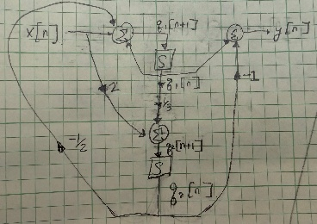
Direct form 1(left): Get recursive equation, write as input and output separate
Direct form 2(right): Switch left and right blocks, combine like terms
Shifts in discrete time$↔$Integral in continuous time
Direct form 1(left): Get recursive equation, write as input and output separate
Direct form 2(right): Switch left and right blocks, combine like terms
Shifts in discrete time$↔$Integral in continuous time
State-var ex: $A=\left[1,-\frac{1}{2};\frac{1}{3}, 0\right];b=\left[1;2\right];c=\left[1-1\right];D=[0]$
General Form State Variable Descriptions: $q\left[n\right]=\left[q_{1}\left[n\right];q_{2}\left[n\right]\right]…$
$$q\left[n+1\right]=Aq\left[n\right]+bx\left[n\right];…y\left[n\right]= cq\left[n\right]+Dx[n]$$
Substitute Vectors: $\left[q_{1}\left[n+1\right];q_{2}\left[n+1\right]\right]=\left[1,-\frac{1}{2};\frac{1}{3}, 0\right]\left[q_{1}\left[n\right];q_{2}\left[n\right]\right]+\left[1;2\right]x\left[n\right]…$
$$y\left[n\right]=\left[1,-1\right]\left[q_{1}\left[n\right];q_{2}\left[n\right]\right]+0x\left[n\right]$$
Expanded: $q_{1}\left[n+1\right]=q_{1}\left[n\right]-\frac{1}{2}q_{2}\left[n\right]+x\left[n\right]…1_{2}\left[n+1\right]+\frac{1}{3}q_{1}\left[n\right]+2x\left[n\right]…y\left[n\right]=q_{1}\left[n\right]-q_{2}\left[n\right]$

